Dear Boulan Family:
Boulan Park Middle School will be visited by local author Jean Alicia Elster on Friday, May 2, 2014. Ms. Elster’s middle-reader book, The Colored Car, has been chosen by the Library of Michigan as a 2014 Michigan Notable Book.
From the Publisher:
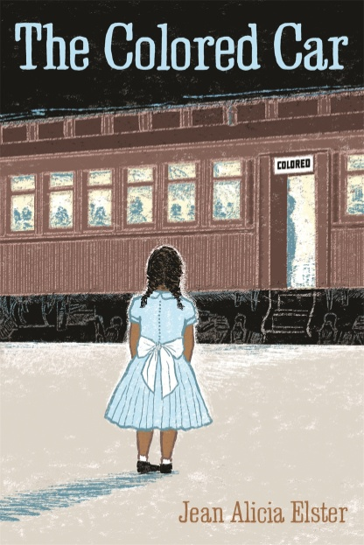
In the hot summer of 1937, twelve-year-old Patsy takes care of her three younger sisters and helps her mother put up fresh fruits and vegetables in the family's summer kitchen, adjacent to the wood yard that her father, Douglas Ford, owns. Times are tough, and Patsy's mother, May Ford, helps neighborhood families by sharing the food that she preserves. But May's decision to take a break from canning to take her daughters for a visit to their grandmother's home in Clarksville, Tennessee, sets in motion a series of events that prove to be life-changing for Patsy.
After boarding the first-class train car at Michigan Central Station in Detroit and riding comfortably to Cincinnati, Patsy is shocked when her family is led from their seats to change cars. In the dirty, cramped "colored car," Patsy finds that the life she has known in Detroit is very different from life down south…By the end of the story, Patsy will never see the world in the same way that she did before. Elster's engaging narrative illustrates the personal impact of segregation and discrimination and reveals powerful glimpses of everyday life in 1930s Detroit.
For more information on the author, please visit http://www.jeanaliciaelster.com.
Sixth grade students as well as a few small groups will be attending the author’s presentation from 9:30-10:30 am in the cafeteria. Ms. Elster will be signing books afterwards.
Students in the Book Discussion Club as well as any student who purchases Ms. Elster’s book are invited to “Lunch with the Author” from 11-11:45 am that day.
If you are interested in pre-ordering the book for your son/daughter, please fill out the following form and return it to your child’s ELA teacher with a check made out to Boulan Park Media Center by Thursday, April 17. Students will receive the books on May 2 in order to get them signed by the author.
Thank you for your support of this worthwhile activity!
Mrs. Christina Chatel
cchatel@troy.k12.mi.us

Cut off this portion and return with check made out to Boulan Park Media Center by Thursday, April 17.

First and Last Name(s): __________________________________________Grade: _____ ELA Teacher: __________
__________________________________________Grade: _____ ELA Teacher: __________
__________________________________________Grade: _____ ELA Teacher: __________

Number of books: __________ x $13.45 = ___________ enclosed

